CSC 134 Homework 2

Specify the following queries on the database schema shown in the following figure, using the operations of the relational algebra. (Total: 100 points)
Submit a PDF file to SacCT.
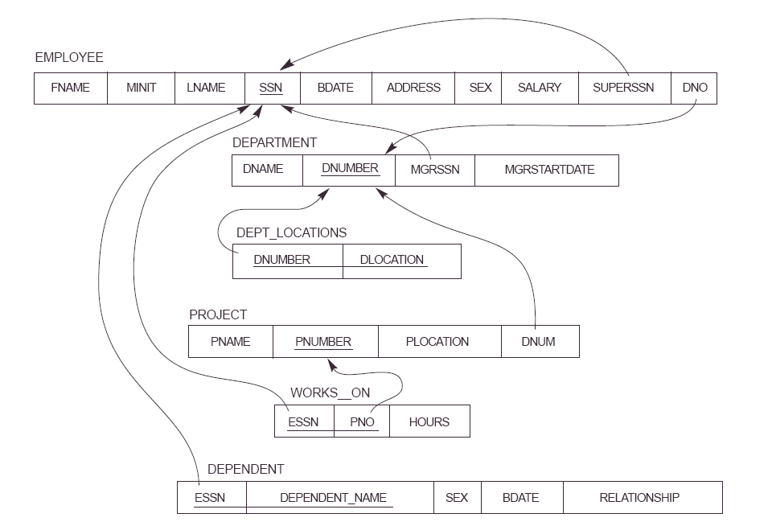

(1) Retrieve the names (fname,lname) of all employees who do not work on any project.

(2) Retrieve the names (fname,lname) of employees who work less than 15 hours per week on the 'River' project. (“River” is project name.)

(3) Retrieve the department (dname) that has a location in ‘New York’.

(4) Find the names (fname,lname) of employees that are directly supervised by 'Mike Morre'.

